Ex. No.:2 Date:18/09/2015
Sinusoidal steady state Response of RLC Circuits

Aim: To state and design the RLC circuits and to verify the output using Pspice simulation software

Apparatus/Tool required:
ORCAD / Capture CIS --> Analog Library – R, L & C
Source Library – Vdc
Ground (GND) – 0 (zero)

Simulation Settings: Analysis Type – Transient (Time Domain)
Run to time: 20ms

Circuit Diagram:
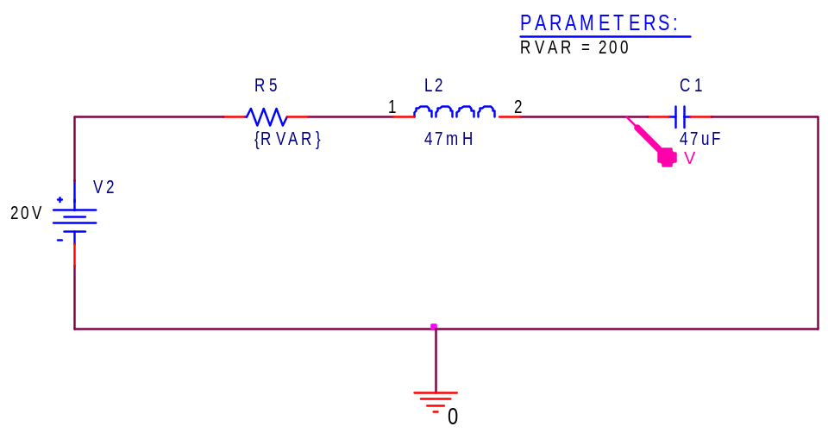
200 Ω
R1
L2
I

Theory:
R(Resistance),L(Inductor) and C(capacitor) have very different phase relationships when connected to a sinusoidal AC supply.
Potential Difference across an inductor leads the current by 90 degrees in phase while that across a capacitor, it lags in phase by 90 degrees.

Formulae :

XL=jwL
XC=-j/wC

For resonant frequency
|XL|=|XC|
wL=1/wC

w*w=1/LC
w=1/sqrt(LC)

2*pi*f=1/sqrt(LC)
F=1/2*pi*sqrt(LC)

Simulation Circuit Diagram:

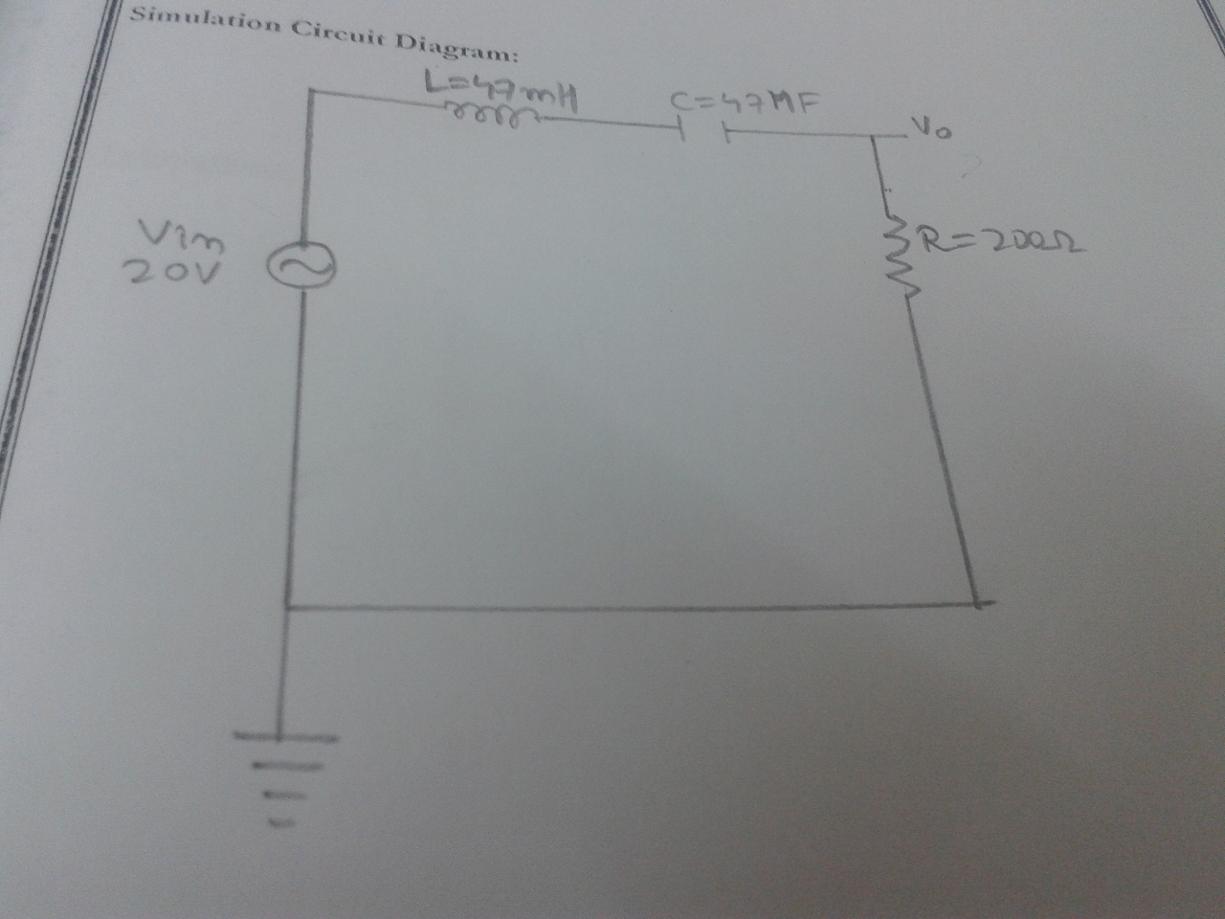

Calculation:

f=1/2*pi*sqrt(LC)
f=10.8 Hz

Tabulation:-

Frequency(Hz) | LOWEST VOLTAGE(V) | HIGHEST VOLTAGE(V) | AMPLITUDE  (MAX-MIN)/2
40 | -18.870 | 17.550 | 18.210
50 | -19.400 | 19.190 | 19.295
60 | -19.750 | 19.210 | 19.480
70 | -19.440 | 19.386 | 19.413
80 | -19.686 | 19.863 | 19.775
90 | -19.839 | 19.572 | 19.706
100 | -19.976 | 19.757 | 19.867
110 | -19.831 | 19.377 | 19.604
200 | -18.596 | 18.707 | 18.652
300 | -17.791 | 17.775 | 17.783
400 | -16.543 | 16.630 | 16.587
500 | -15.330 | 15.370 | 15.350

Procedure:-
1} Open the PSpice project and construct the circuit as per the diagram.
2}Run the simulation under the analysis type, transient and note down the value of peak voltage(both maximum and minimum)at the end of the graph.
3}Repeat the experiment starting from 40Hz to 100Hz increasing by 10Hz.Each time on reading 100Hz increase by 100Hz till 500Hz.

Result:-
Sinusoidal steady state response of RLC circuit has been verified using PSpice simulator and the graph has been obtained for the same.

Inference:-
At low frequency the RLC circuit behaves as capacitor. At high frequency, it behaves as indicators and at resonant frequency, it has least resistance.

